Aquaveo GMS: <https://aquaveo.com/software> Also on the app portal.

USGS ModelMuse: ModelMuse is a GUI for MODFLOW 6, MODFLOW-2005, MODFLOW-LGR, MODFLOW-NWT, MODFLOW-CFP, MODFLOW-LGR, MODFLOW-OWHM, MT3DMS, MT3D-USGS, SUTRA, WellFootprint, PHAST, MODPATH, and ZONEBUDGET.

USGS ModelViewer: Model Viewer is a program for 3D visualization of groundwater-model results.

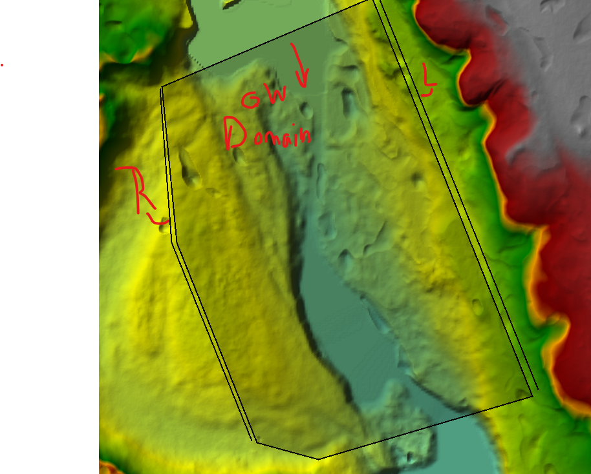

Inputs

1. Polygon extent for groundwater domain (shapefile)
2. Left polyline for floodplain groundwater (shapefile). Assume single WSE (ft), or 2 WSE’s (start and end WSE along line).
3. Right polyline for floodplain groundwater (shapefile). Assume single WSE (ft), or 2 WSE’s (start and end WSE along line).
4. Uniform and constant Hydraulic conductivity (K)… ft/day
5. 3D Grid information (X spacing, Y spacing, Z spacing) Number of layers
   1. Top Elevation for the grid … ask user for single value
6. Water surface elevation (raster) ft
7. Projection from RAS
8. Run type: Assume steady state model runs

Steps

1. Delete contents of project folder if it exists…
2. Create project folder to store…
3. **MODFLOW MODEL**
4. **GRID** SETUP: Create 3D grid from the polygon extent for groundwater domain (user specified number of layers and depth per layer). X and Y distance for each cell (e.g., 5-10 ft). Specify top grid elevation (single value)
5. PLACEHOLDER – STRETCH TOP ELEVATION OF TOP LAYER TO TERRAIN
6. Create a shapefile for the WSE raster and figure out how to get FLOPY to know about the BC (Constant Head – CHD)
   1. CHD boundaries applies
7. Create CHD boundary conditions for the Left and Right floodplain groundwater
8. **LPF PACKAGE**: Uniform hydraulic conductivity applied
9. **PCG solver** setup
10. Run Modflow Model
11. Post-processing – plot the grid with the hydraulic head contours